IRI Ondemand factory
Version 1.0
Rule Engine (Across the Factory)
Conceptual Framework
Table of Contents

Overview (Definition) 2
Overview (Diagram) 3
Solution Definition 5
Stress Points 8
Assumptions 8
Dependencies 8
Measurement of Work (Unit of Processing) 8
Issues (Business & Technical) 8
Risks 9
POCs 9
Next Steps 10

Overview (Definition)
The proposed architecture is a rule engine architecture that can be used at each of the decision points in the complete factory process. Some examples of use are:
- Store Level QC
- UPC Level QC
- Projections
- Releasability
- Product Configuration
- Security

This architecture will keep the decision making rules separate from the code. The engine is a Java class that is embedded into the code. The rules for each rule engine can be stored either in a database or in an XML file that the engine reads at runtime. You can change the rules without changing or recompiling the code. If you change the rules, the next time the code runs the new rules will be used. You can have as many engines running as needed. The rules are divided into rule sets. If needed, you can have a separate rule engine for each rule set.
The rules have a very fine granularity. Each rule has a very small functionality. Each rule covers one small task. Each rule is independent of other rules in the system. An example could be:
IF
The applicant’s state of residence is VA
And the applicant’s age is less than 18
THEN
Raise the premium by $28 with the reason “VA young driver premium”

IF
The applicant’s state of residence is VA
And the applicant’s age is greater than or equal to 25
THEN
Lower the premium by $20 with the reason “VA adult driver premium”

A good business rule system deals with 5 major areas:
- Business Rule Management
- Business Rule Authoring
- Business Rule Testing and Debugging
- Business Rule Deployment
- Business Rule Lifecycle

Overview (Diagram)
The diagrams below are from ILOG JRules.
Diagram 1 deals with managing business rules. All rules are stored in a central rule repository where they are stored, categorized, version controlled and published. The Technical user (Knowledge Engineer) designs the rule templates and develops the rule language. The business user (Business analyst) uses this information to develop business rules.
Diagram 1: Business Rule Management

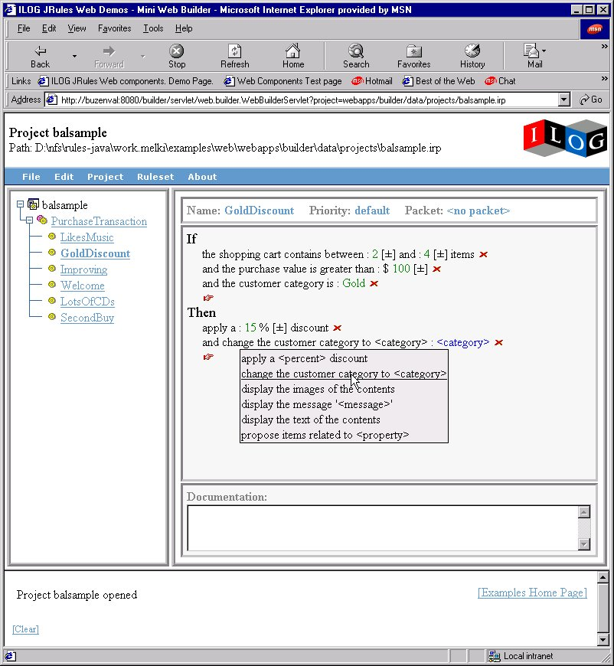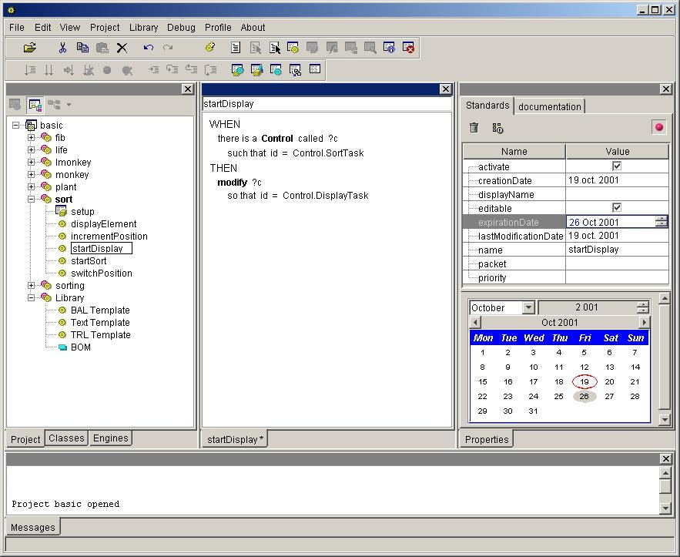
Business
User
Technical
User
Releasability
StoreQC
Repository
Rule Builder IDE
Rule Builder
Web Rule Editor
…
Author
Manage
Deploy

Diagram 2 shows the business rule authoring and execution environment. The Knowledge Engineer develops the rule language and the Business Object Model using the rule builder. The Business Analyst then develops the rules using the rule editor. All the information is stored in the central business rule repository. It is the published out to the execution environment as and executable object model.
Diagram 2: Business Rule Authoring

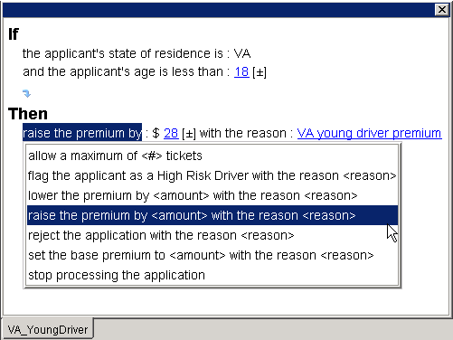

Rule Editors
Executable Object Model (XOM)
XML
Java
Web
Services
Custom

Rule Engine
Authoring environment
Execution environment
Business Object Model (BOM)
Rule Languages

Rule Builder

Repository
DBMS
Other Editors

Diagram 3 shows the business rule testing and debugging diagram. Business rules are validated using a consistency checker. The business rules can then be tested using the debugging, tracing and profiling in the musiness rule building environment or in the actual application.
Diagram 3: Business Rule Testing and Debugging
Application
Static
Rule Validation
Consistency Checking
Dynamic
Debugger
Full real-time execution control
Remote linking
Tracer
Accessible in Rules Builder or application
Profiler
Display rule execution statistics

Testing and debugging

Debugger
Tracer
Profiler

Rule Validation
Consistency Checker

Diagram 4 shows how the business rules are deployed. The business rule engine is integrated into the application. When you publish a rule set, it is deployed from the rule repository to the actual application. These rules are then used by the integrated rule engine. The working memory is where the Java objects are that the rules actually read from and write to during the running of the rule engine.
Diagram 4: Business Rule Deployment
Rule Engine

Working memory

Ruleset

Repository
Deployer

Rule Engine Integration
Rule Engine integration
Java
J2EE
Deployed
Rules +
Ruleflow
Application
objects
Java
XML
EJB

Ruleset

Diagram 4 shows the business rule lifecycle. This is all handled by the Business Rule Management System (BRMS). The rules are defined, deployed, maintained and retired all within the central rule repository.
Diagram 5: Business Rule Lifecycle
Business Rule Management System (BRMS)
A BRMS provides tools for authoring, deploying and managing business rules throughout their lifecycle
Definition
Deployment
Maintenance
Retirement
Create
Edit
Store
Report
Search
Templatize
Organize
Reuse
Revise
Track
Report
Store
Distribute
Validate
Implement
Test
Debug
Trace
Report
Store
Deploy
Archive
Report
Search
Organize
Business Rule Lifecycle

Solution Definition
The problem is how to deal with business rules. We have the hidden away in many different programming languages, in people’s heads and in many documents. These are all places that make it hard to extract the rules. We need to have all IRI business rules in a central storage area so that they become a corporate asset. By using a commercial business rule system like JRules from ILOG, we can start the process of getting all the business rules in one location that can be managed. Since we are building a new factory from scratch, this is a good time to start the process.

Stress Points
There are many stress points in this process:
- Finding the needed business rules
- Even after the business rules are found, they will have to be extracted
- Finding subject matter experts that still understand the old processes
- Doing the knowledge acquisition necessary to develop new business rules
- The time needed for knowledge acquisition and initial setup

Assumptions
The following assumptions need to be made:
- We will have a commercial business rule system at the caliber of JRules from ILOG
- We have subject matter experts that understand the decision making process of their subject
- We have resources that can do knowledge acquisition with subject matter experts
- We have resources that can read the code of existing systems and pull out business rules
- Any new software that has decision making as part of it will be written in Java
- We have Java programmers
- We will have a knowledge engineer to maintain the rule system
- We will bring in a consultant from the commercial business rule system company

Dependencies
The major dependency is how to incorporate the needed rules engines in the factory process. How will we feed the business rule system and how we will pass the information from the business rule system to the rest of the processes? This will depend on how we set up the information pipeline.

Measurement of Work (Unit of Processing)
The unit of work is very fine grained. It is as the rule level. However, the rules will be categorized into larger units of work called rule sets. The final unit of processing , the one that the rest of the systems see, is at the rule engine level.

Issues (Business & Technical)
Business Issues/Questions:
- Will the business resources understand rules?
- What training will the business analyst need to write rule?
- How long will the training take beyond the course work?

Technical Issues
- Do we train people to be a knowledge engineer or do we hire them?
- If we train them, how long will it take?

Risks
I feel that the major risk is not using a commercial rule system to deal with our business rules. With a rule system the following risks have to be taken into account:
- Will we get the scalability needed to deal with our volumes and complexity?
- Will we be able to deal with conflicting rules, missing rules and rule that are not specified correctly?
- Will we take the time needed to develop the business rule environment so that we can reap the benefits that will be gained in managing the complete lifecycle?

POCs
- Projections: This would show that the rule system can handle the needed level of complexity. We can develop the system using ACV calculation rules and projection weight rules.
- Store Level QC: This would show that the rule system can handle the volumes that we need. The rules will be used to decide whether we accept the incoming scan data and move it to UPC Select or whether we have to impute it. Diagram 6 shows how the rules will fit into this process.

Diagram 6: Store Level QC POC Architecture
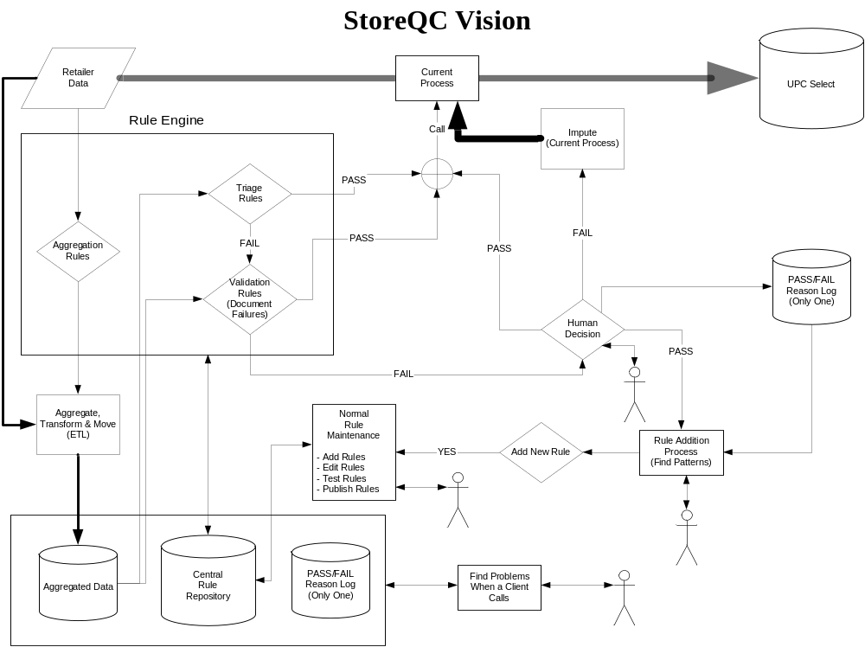

Next Steps
- Evaluate the top commercial business rule system vendors
- Select the vendor that we want as a partner
- Decide which POC to do
- Start the design of the POC that has been selected

